Pre-Lab 3: EEG and recording EEG

Quiz Instructions

This quiz is open media. The questions and answers are based on three videos found on this webpage.
"EEG basics part 1" watch 5 min 44 sec through 7 min 15 sec
watch 30 min 17 sec through to the end
"EEG basics part 2" watch 5 min 3 sec through 14 min 55 sec
watch 23 min 1 sec through 27 min 35 sec
"EEG setup, recording, cleaning procedures" watch all of this one

EEG records electrical activity _____
throughout the brain
directly from the cortical surface of the brain
through the skull and from the cortical surface of the brain
from the entire nervous system

Why is it important to know where your electrodes are relative to brain's cortical surface?
It's not - why would we even care about this?
depending of where we see the most electrical activity, we can infer different things because different areas of cortex are specialized to do different things
depending on where we see the most electrical activity, we know what the brain is up to because we have mapped specific behaviors onto specific cortical locations
if an electrode shorts out, we must be able to assess which part of the cortical surface might have been impacted

EEG is recording ___
IPSPs and EPSPs
only IPSPs
only EPSPs
action potentials

EEG records activity on the ________ of _______

dendrites : sensory neurons
dendrites and soma : all types of cells
axons : pyramidal cells
dendrites : pyramidal cells

If you are told that the frequency of a waveform is 10 Hz, the means ______
nothing important
there are 10 peaks in the waveform every 60 seconds
there are 60 peaks in the waveform every 10 seconds
there are 10 peaks in the waveform per second

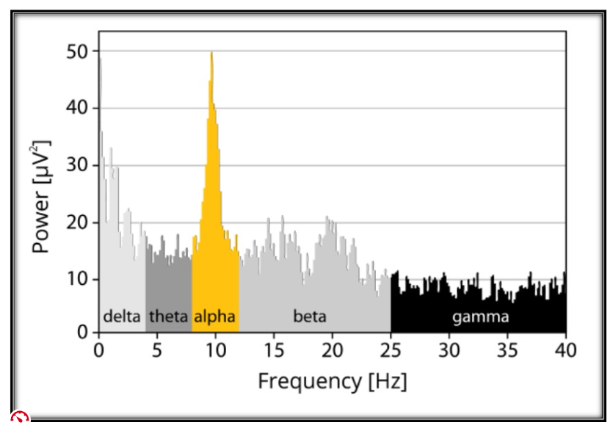
This graph (above) is telling us that _______

gamma has the greatest power
frequencies in the 8-12 Hz range have the greatest amount of electrical energy
alpha has the highest frequency
F&%$#

What is the relationship between impedance and signal quality?

they are not related
as impedance goes up, signal quality goes up
as impedance goes up, signal quality goes down
impedance is a constant whereas signal quality is a variable

When an EPSP is generated ___

current flows toward the brain's surface and the waveform deflects up
current flows toward the brain's surface and the waveform deflects down
current flows away from the brain's surface and the waveform deflects down
current flows away from the brain's surface and the waveform deflects up

When you see an EEG waveform on the computer screen, what you are seeing is _________

Magical
electrical activity under a single electrode
the difference in electrical activity between the active electrode and a reference electrode
the sum of electrical activity between the active electrode and a reference electrode

In our lab, we use "active electrodes". This means _______

they have built in amplifiers to magnify the signal
they actively control for eye movement artifacts
they actively control for any type of artifact
they filter out 60 Hz noise that might be coming from other electronic devises in the room

When connecting wires to the amplifier or battery, it is critical to ________
Group of answer choices
listen to your favorite tunes and or have an animated conversation with someone else
twist the wires counter clockwise
twist the wires clockwise
NEVER twist the wires

Before you connect the electrodes to the amplifier, it is IMPORTANT that you first ______
pray that nothing goes wrong
connect the ground electrode to your participant
connect all electrodes to your participant
do nothing - just connect all the electrodes to the amplifier

You should choose a cap that is _____ than the circumference of the participant's head.
one size larger
one size smaller
the same size as
it makes no difference

The instructions for setting up the EEG, connecting the participants, and using the recording software are ____
nowhere to be found
found only in the setup and recording video
in printed instructions found in the EEG lab
found on google

Before the electrodes can be gelled and installed into the cap, it is CRITICAL that
Fp1 and Fp2 be gelled and green first
Fp1 and Fp2 be gelled and green last
fz be gelled and green first
it make no difference which is gelled and green first

Before you insert an electrode into the electrode cap, you must first ______
tuck aside all the hair that is inside the hole under the cap to expose the scalp
make sure that as much hair as possible remains in the hole
clean the scalp in the hole with a Q-Tip doused in alcohol
bring all of the hair that is in the hole outside so it hangs on top of the electrode cap

When inserting and removing electrodes into and from the cap ___________
give them a quick tug and push respectively
NEVER twist or pull the wires
put generous amounts of electrode gel in and around the hole so that essentially the entire cap is gelatinous
hold your breath and ask the participant to do the same

The dongle that runs the software must always be ______ when not in use.
in Lynn's office
in the computer's USB port
in the large hard shelled EEG case
in the box stored at the back on the desk drawer

Which of the following statements about washing the EEG electrodes is TRUE? Select all that apply.
use barely warm water
attach the cable to the FRONT of your shirt
never let the splitter box get wet
hold each electrode by the wire
use a toothbrush to remove the gel from each electrode
use soap

To clean the cap _____
bring it home and wash it
give it to Lynn - she has a special washing machine designed for cap washing
let it sit in a sink with warm soapy water for 10 min then rinse well
run it under warm water and make sure all the gel is rinsed out

It is clearly evident that _____
Lynn is anal
EEG setup, recording, and cleanup have rules that must be meticulously followed
EEG is impossible to master
everything about EEG is so easy – even a caveman could do it

