SARA Quiz Questions Grading Rubric

You need to create 3 multiple-choice (MC) questions, each with four options. Clearly indicate which of the four options is correct. Note that "good" options are those that are not obviously bogus (though you are allowed to have one that is - just to add some humor :) The questions must be meaningful and relevant to your SARA presentation. Writing great MC questions is really challenging! I strongly recommend having someone you know (and trust to be honest) give you feedback on whether your questions and answers are clear and unambiguous.
Each question will be scored as follows:
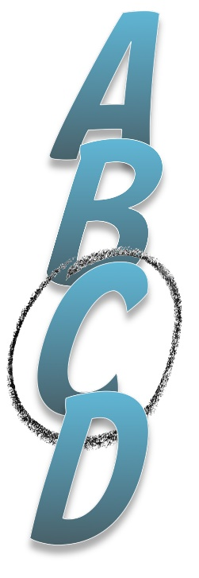
the question was well written (1)
the question was meaningful and relevant to the SARA question (1)
the answer was easy to get but not directly printed on a slide (1)
at least 3 of the 4 options provided were "good" options (1)
the correct option was clearly indicated (1)

